Lathe Theory 101

Name: ________________________ Block: _____ Date: ______________

Textbook: Machining Fundamentals – John R. Walker

Terms to Define:

Compound Rest
______________________________________________________________________________

Cross-Slide
______________________________________________________________________________

Depth of cut
______________________________________________________________________________

Facing
______________________________________________________________________________

Headstock
______________________________________________________________________________

Turning
______________________________________________________________________________

Single Point Cutting Tool
______________________________________________________________________________

Tail stock
______________________________________________________________________________

Tool Post
______________________________________________________________________________

Label the machine!

I am not expecting you to know all the names of every single part but I do want you familiar with the ones you will be using most. Label the following parts.

The names might be different depending on which resource you are using (textbook vs website)
Headstock | Saddle/Carriage | Lead Screws
Tailstock | Compound/cross/top slid
Chuck | Emergency Stop
Toolpost | Lathe bed/ways

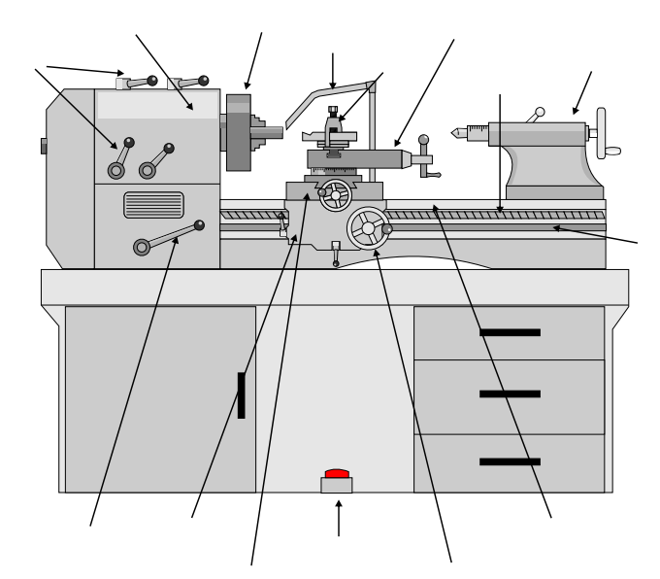

Image found at
http://www.technologystudent.com/equip1/mlathe1.htm by V. Ryan

Questions about the Lathe! Found in the textbook (Ch 13 Starting at Page 201)

1) The Lathe operate on the principle of:
a. The cutter revolving against the work.
b. The cutting tool, being controllable, can be moved vertically acros the work.
c. The work rotating against the cutting tool, which is controllable.
d. All of the above.
e. None of the above

2) Explain the purpose of the WAYS on the lathe bed:
__________________________________________________________
__________________________________________________________

3) The carriage supports and controls the cutting tool. Describe each of the following parts.
a. Saddle/Carriage
__________________________________________________________

b. Cross-slide
__________________________________________________________

c. Compound rest
__________________________________________________________

​d. Tool Post
__________________________________________________________

4) Accumulated metal chips and dirt are cleaned from the lathe with a ____________, never with ____________.

5) Which of the following actions are considered dangerous when operating a lathe? (you may choose more than one answer....)
a. Wearing eye protection
b. Wearing loose clothing and jewelry
c. Measuring with work rotation
d. Operating lathe with most guards in place
e. Using compressed air to clean the machine.

6) In most lathe operations you will be using a single-point cutting tool made of __________
(hint.... in our shop it may be different than the textbook.... maybe ask your teacher.....)

7) What does cutting speed indicate?
__________________________________________________________

8) Most work is machined while supported by one of four methods. List them!
__________________________________________________________
__________________________________________________________
__________________________________________________________
__________________________________________________________

17) Sketch a correctly drilled center hole and a bad one (you might find this near page 224-225)
Good | Bad

18) When using the parting tool, the spindle speed of the machine is about _________ the speed used for conventional turning.

​19) There are many safety precautions that must be observed when operating the lath. List what you consider the five most important.
1)_________________________________________________________
2)_________________________________________________________
3)_________________________________________________________
4)_________________________________________________________
5)_________________________________________________________

