Woodwork Alphabet Assignment
Name:
Block:
Date:

This Alphabet assignment is a research and knowledge exercise.
For this exercise you will need to fill in each letter of the alphabet with a type of wood, a tool, a safety rule, or piece of woodworking equipment, description about it, and photo. You may use any resources you have (books, internet, home garage/tools, etc) to do these. Feel free to use some humor with this as long as it does relate to the assignment!
How to find answers? Type in “wood work tool list” or “wood work safety” or “types of wood” in a search engine. You can get as creative as you want with this! You are more than welcome to use wikipedia or something for your descriptions. I did that for the examples below.
How to add an image in a Google Document:
Top menu -> Insert -> “Image” -> choose your option. I personally like to save an image to my device and upload it but you can easily press “Search the web” and easily insert a picture without needing to save it (unless it is has copyright). WOW! I like to save them or take a screenshot!
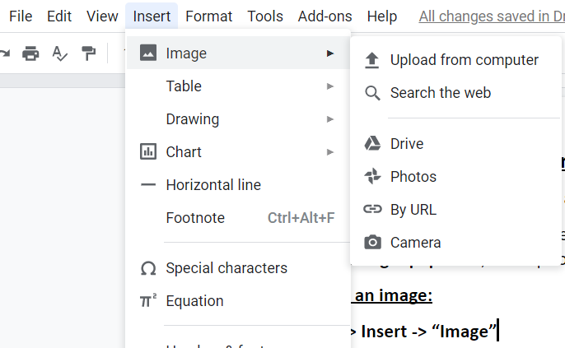
Examples:
Insert picture here:  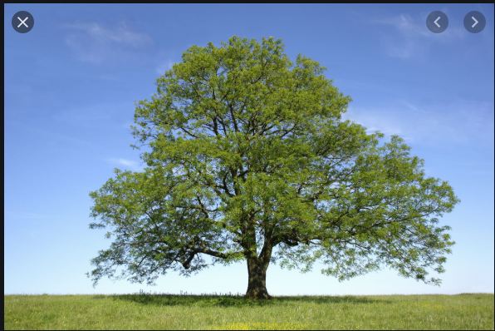 | A is for: Ash tree  Ash is a hardwood and is hard, dense, tough and very strong but elastic, extensively used for making bows, tool handles, baseball bats, hurleys, and other uses demanding high strength and resilience.

Insert picture here:  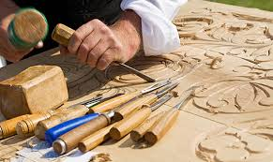 | C is for: Carving  Wood carving is a form of woodworking by means of a cutting tool (knife) in one hand or a chisel by two hands or with one hand on a chisel and one hand on a mallet, resulting in a wooden figure or figurine, or in the sculptural ornamentation of a wooden object.

YOUR TURN!
Insert picture here: | A is for:

Insert picture here: | B is for:

Insert picture here: | C is for:

Insert picture here: | D is for:

Insert picture here: | E is for:

Insert picture here: | F is for:

Insert picture here: | G is for:

Insert picture here: | H is for:

Insert picture here: | I is for:

Insert picture here: | J is for:

Insert picture here: | K is for:

Insert picture here: | L is for:

Insert picture here: | M is for:

Insert picture here: | N is for:

Insert picture here: | O is for:

Insert picture here: | P is for:

Insert picture here: | Q is for:

Insert picture here: | R is for:

Insert picture here: | S is for:

Insert picture here: | T is for:

Insert picture here: | U is for:

Insert picture here: | V is for:

Insert picture here: | W is for:

Insert picture here: | X is for:

Insert picture here: | Y is for:

Insert picture here: | Z is for:

