03. Scrap Wood Birdhouse
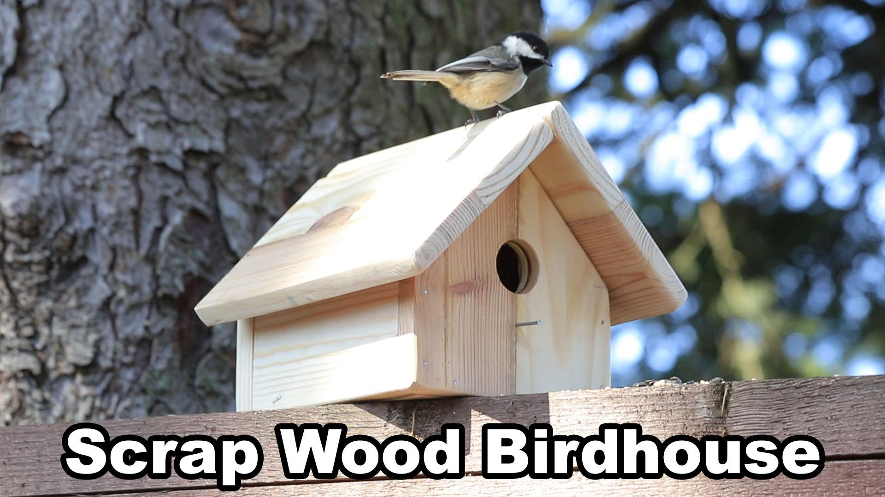

Name:
Block:
Date:

Activity Webpage: https://holbrooktech.weebly.com/scrap-wood-birdhouse.html
Video: https://youtu.be/_7Yz-qKbHWM

You have a choice with this activity and this will most likely be the case for many of the future activities.
Build something or do a worksheet!
​
If you already have a wood project and tools at home that you can work on then document with photos or video and attach them to the google classroom response for this activity (if you already have a table, or wood projects in progress then do that instead of these questions).

If you have tools and wood and want to build this project or something similar (different design but still a birdhouse!) that is awesome but optional. The project shown in the video is very beginner level but if you are limited to simple tools it does make it a little hard compared to having a real wood shop available.

If you are not able to try the practical activity here are some questions related to the video that you can answer.

Video Questions:
1) I was able to use "reclaimed lumber" from some old pallets. Where around town could you source free materials like this if you really needed or wanted to? I don't need a name and address but research at least 2 places you could get material from and what kind would it be.

2) a.What is the purpose of "laminating" wood?

b. What important things to you have to check for when laminating wood. List the ones I talked about in the video and add more if you know more.

c. What would this project have looked like if I had only used nails and no glue?

3) Aside from having the wood available in my garage why do you think I chose to use this reclaimed wood? *hint. I say it a bunch of times in the video!

4) Why do I clamp/secure the material to the work table when cutting and drilling?

5) I got frustrated with my "aggressive wood saw" and used a different saw at one point. What was the difference between the two saws and why do you think the 2nd one (the bi-metal blade) was easier to use?

6) Why do I score/go backward/pull toward (best way to describe it!) with the saw when starting a cut?

7) Glue questions: What was the purpose of me adding glue to the "END GRAIN" of the wood and letting it sit? Why do you think end grain sucks in glue compared to gluing faces or edges/sides of wood?

8) What is the obvious difference between the two nail choices I show in the video? Why is nail/fastener choice important in a project like this (think long-term...)

9) Why would I "pre-hammer" nails and how does this make my project easier?

10) Why would the hole size of a birdhouse matter? Why not make it twice as big?

11) Research the "house" volume and hole size required for a different type of bird than what was shown in the video. List your answer.

Bonus Question!!
x) What did you think of that cool video transition at 11:15! How do you think I did that? Did you notice it was two separate shots?

