Bring the Hammer down!  Name: ______________________  Block: ____  Date: _____________ | 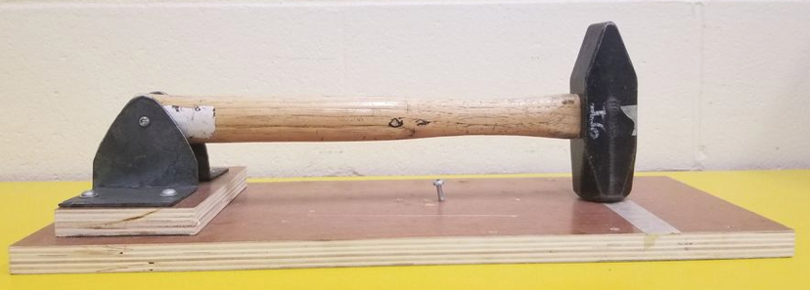
Design Challenge:

Your challenge is to build a simple machine that will harness the power of a falling hammer in order to shoot a ‘standard size soaking wet tennis ball’ the furthest distance possible. The wet mark on the ground from the ball will be an indication of distance travelled from the “hammer impact point”.
As the hammer falls from a 90 degree (horizontal position) it should impact/hit your simple machine causing a chain reaction, catapult type motion, elastic forces, etc that shoots the ball the furthest possible distance.

Project Size: Individual or groups of 2. Groups of 2 are expected to do twice the work

Materials:
- Just about anything we can find in the shop. The total $$ amount of material used should not exceed $10 so we will try and utilize scraps and short ends as much as possible. PLEASE DO NOT CUT MATERIAL UNTIL CHECKING WITH THE TEACHER FIRST
- Wood, metal, plastic, old toy parts, cardboard, bungie cords, etc. Go for it!
- Wood is usually easier to work with but if you want specific parts made from metal for strength (axles, etc) than ask the teacher for help on creating what idea you have.
- Small 3D printed parts IF TIME AND MATERIALS ALLOWS.

Limitations:
The footprint/base of your project should not exceed 24"x24" (60cmx60cm) and it should not weigh more than 15 pounds. Please have materials/products approved during the design portion of this project.

Design time!
Before you begin construction, you should begin by creating an idea map and any research you may need to harness the power of gravity and weight in order to transfer energy.

Plans, Prototyping, and timeline:
2 classes will be provided for research. The three computers or your mobile device may be used to gather ideas of physics concepts and/or how a simple machine/catapult can be harnessed to transfer the energy from the hammer to a high-flying ball! Use your time wisely as you are expected to begin the blueprint and prototype stage by day 3.

4 classes will be provided to create a working mini or full-size prototype in order to measure the success before moving onto the final versions.

Blueprints (even rough ones) with measurements and 90% of what you think will be required to build are necessary before you are allowed to begin creating your final project.
​
Marks/Rubric
Plans/Design _____ 50
-Orthographic plans, research, mind maps, rough drafts, drawings on napkins, etc
-Daily design journal recording your daily progess (lined paper in your engineering binder will suffice and will need to be handed in when project comes to an end)

Aesthetics/Build Quality/Function _____ / 20
Does is look symmetrical?
Does it look like it came from a garbage can?
Does it function smoothly?
All parts given quality care and attention?
ETC

Distance _____ / 30
Marks will be scale-based on the class average and farthest throw

TOTAL _____/100

Learning Standards:
- Make decisions about premises and constraints that define the design space, and develop criteria for success
- Generate ideas to create a range of possibilities and add to others’ ideas in ways that create additional possibilities
- Evaluate suitability of possibilities according to success criteria, constraints, and potential gaps, and prioritize for prototyping
- Choose an appropriate form, scale, and level of detail for prototyping, and plan procedures
- Visualize and construct prototypes, making changes to tools, materials, and procedures as needed
- Record iterations of prototyping
- Develop an appropriate test of the prototype, conduct the test, and collect and compile data
- Create design, incorporating feedback from self, others, and results from testing of the prototype
- Use materials in ways that minimize waste
- Critically reflect on plans, products and processes, and identify new design goals
- Apply safety procedures for themselves, co-workers, and users in both physical and digital environments

Physics concepts to explore during this project:
- ideas, rules, or concepts from physics that inform approaches to an engineering problem (e.g., kinematics, relative motion, dynamics, momentum and energy, electromagnetic forces and induction)

