Historic Weapons Activity

Name:
Block:
Date:

Teacher Webpage: https://holbrooktech.weebly.com/06-historical-weapons.html
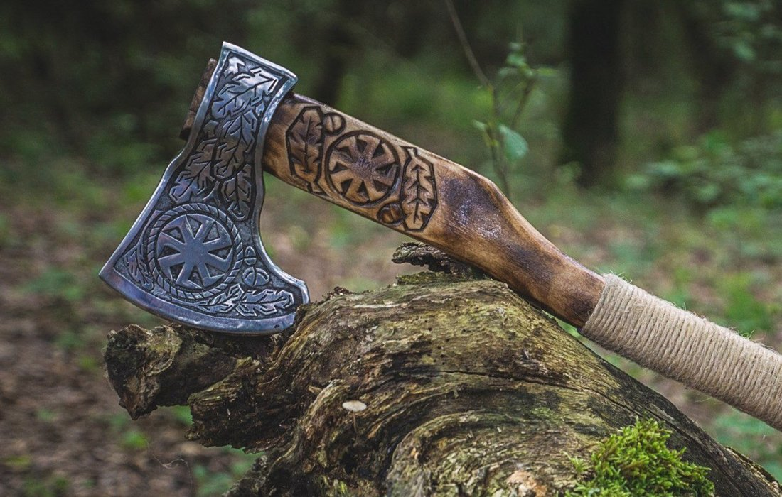
Overview:
One of the greatest lessons that history has taught us is that to move forward with the future we have to learn from the past. Instead of looking up old technology from metalwork as in all honestly, some of the technology is still relevant even today this activity allows for some fun to look up famous weapons or styles of weapons as that is a lot more interesting than talking about the improvements in welding for example!

​Assignment:
You will be researching a historical weapon or style of weapons, for example, the Dane Axe used by the Vikings or William Wallaces’ long sword. I’m not going to make you write a paper although for those that choose they can. You can present this in any way that you choose as long as it meets the requirements below.

​Requirements:
-This should be 500 words or one-page worth of information no matter the media (report, slideshow, home-made video, etc).
-What is special about this weapon, for example, the Dane Axe has its blade curved to help pull away shields.
-How is it constructed?
-The materials used and are they special in any way (copper, bronze, iron, steel, etc)?
-What "age" was your weapon used in (bronze age, iron age, stone age, old age, etc)?
-Why is this weapon made this way?
-Some historical context to the weapon.
-Cool facts about the style or weapon.

Time Required:
You should put in roughly 2-3 hours’ of work on this. ​​

​

