Units of Measurement – Metalwork
Name: __________________ Block: ____ Date: ________________

What are the two main units of measurements used in North America?
_________________________ ______________________
Imperial System
First defined by the British in the 1800's
Lengths: mile, yard, foot, inch​
Canada continues to use the Imperial System when trading with goods with the USA
Imperial Measurement Tips:
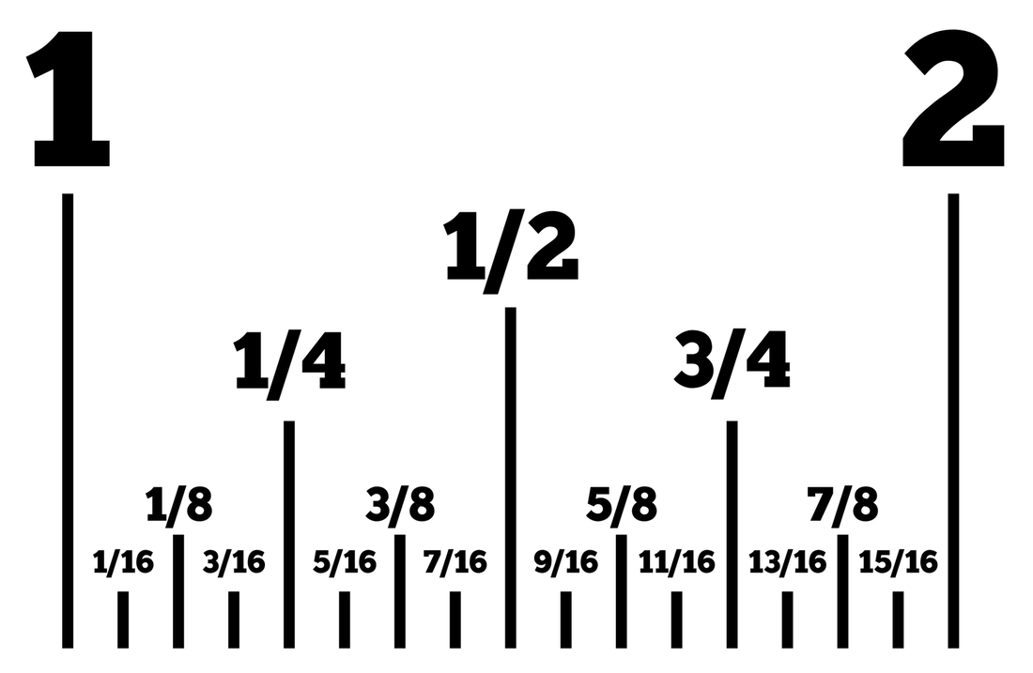
Fill in the answers to the 12 Times Table
12 x 1 = ___ | 12 x 4 = ___ | 12 x 7 = ___ | 12 x 10 = ___
12 x 2 = ___ | 12 x 5 = ___ | 12 x 8 = ___ | 12 x 11 = ___
12 x 3 = ___ | 12 x 6 = ___ | 12 x 9 = ___ | 12 x 12 = ___
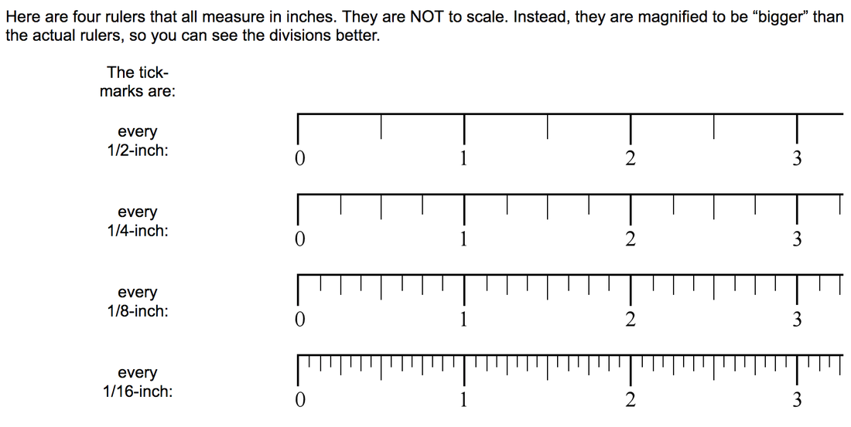
You must remember to simplify your fractions
For example:
12 ticks = ____ /16ths of an inch
Divide the numerator and the denominator by 4.
Remember: Whatever you do to the top number you must do to the bottom number

12 divided by 4 = ____
16 divided by 4 = ____
Simplified fraction - 12/16" = _________ of an inch (simplified fraction answer) or _________________________________ (full written word answer).
Conventions (symbols) how to express inches and feet in your answers
All are correct but we will use the last convention showing only the symbols of feet and inches
1 foot = 1ft = 1'
1 inch = 1in = 1"
Convention Samples:
2 feet and 3 inches will be expressed as follows:
__’ __"

2 feet 3 and 1/6th of an inch will be expressed as follows
__’ __ ____" The inch mark goes at the very end of the fraction of an inch

Metric System
Most used system of measurement worldwide (ie: Canada, Europe)
Lengths: kilometer, meter, centimeter, millimeter
Canada adopted this system in 1970 to replace the Imperial System

Let’s practice on the next pages!

Imperial Measurement – Answer with a fraction in inches!
Don’t forget to simplify your fraction ( 2/4” would be 1 /2” ).
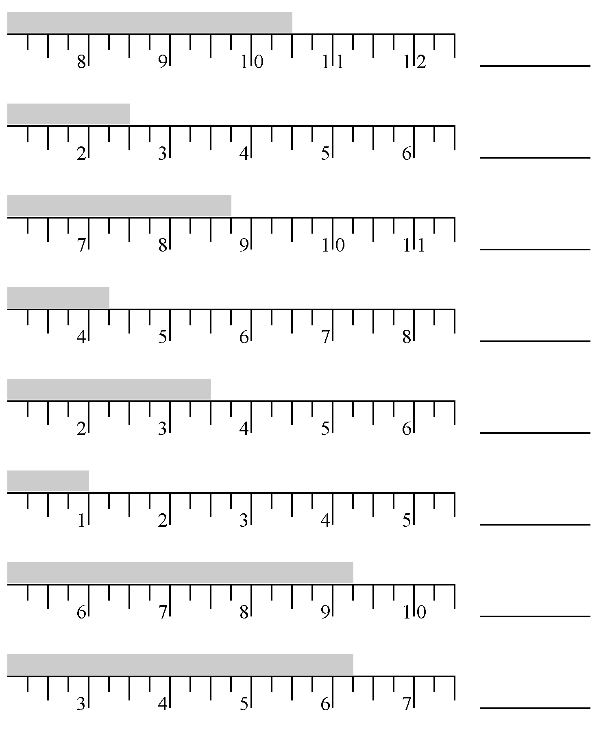
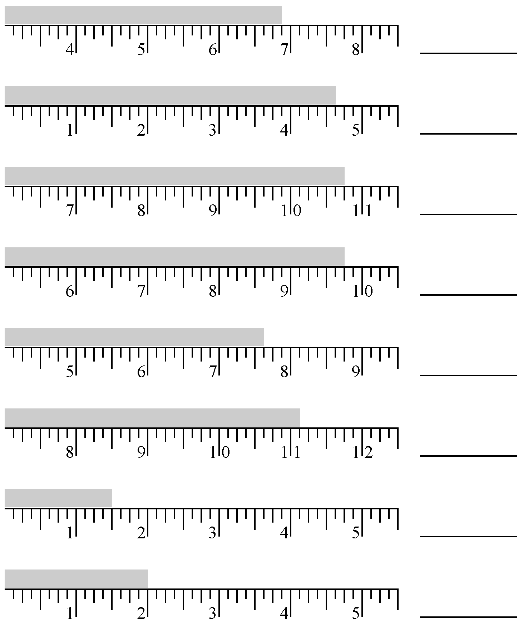
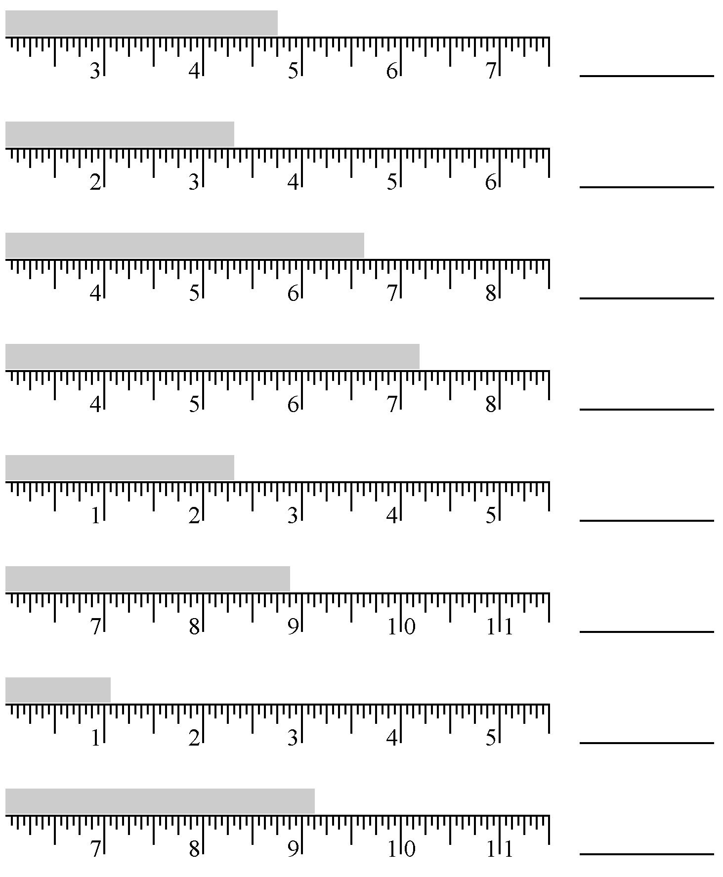

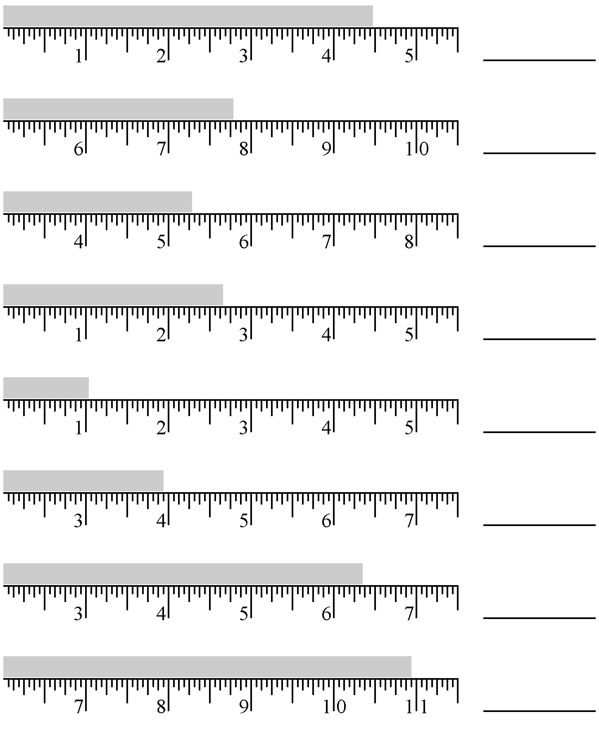
Measure in length of the rectangle in inches using a REAL ruler
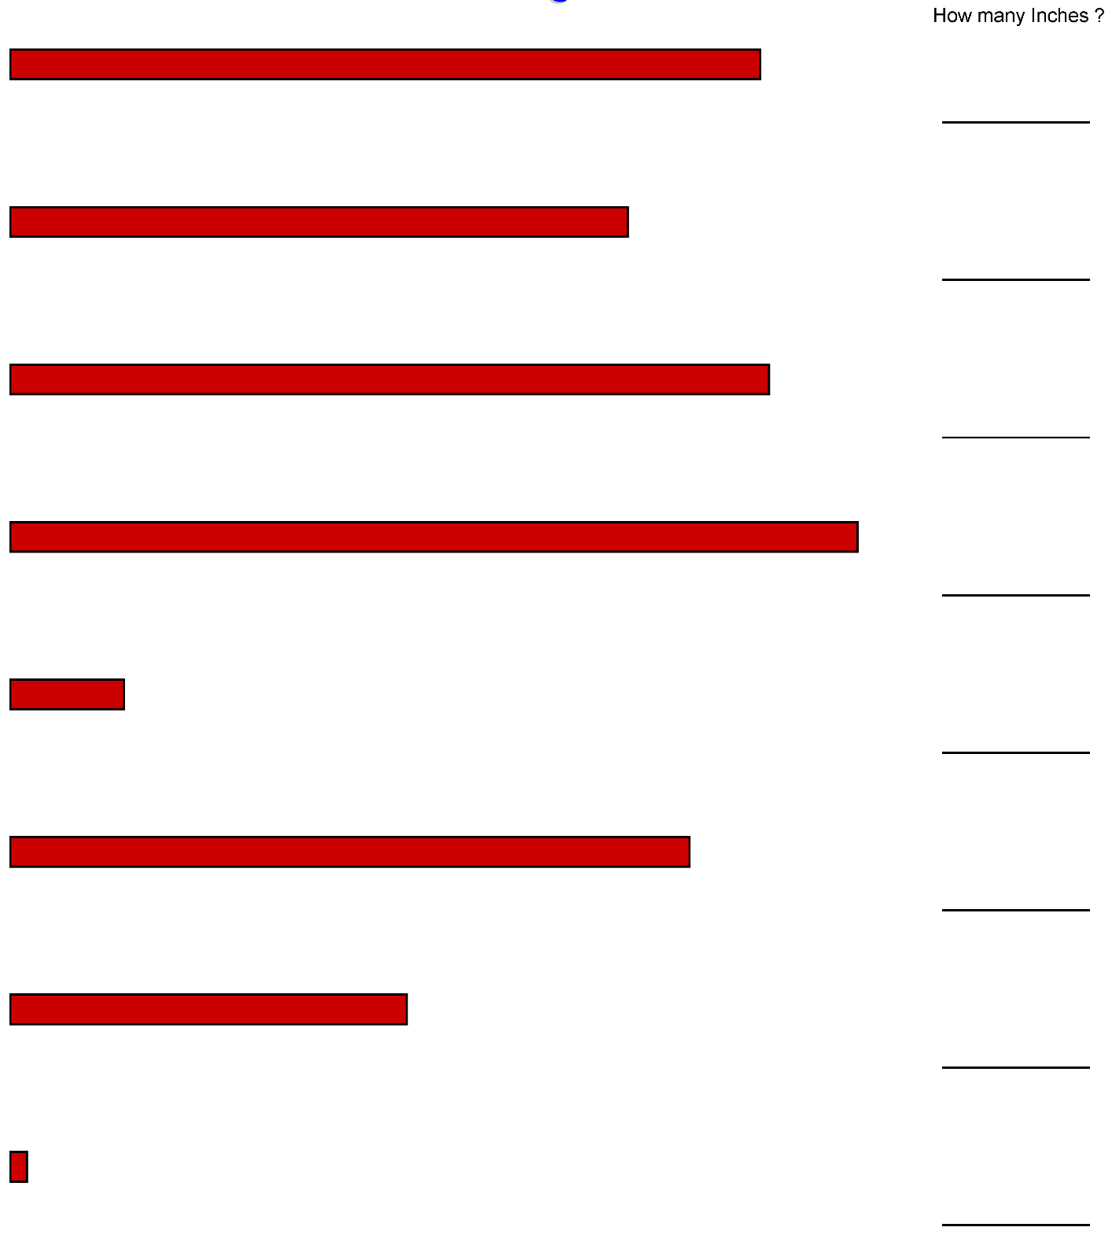
Measure the length of the rectangle in inches using a REAL ruler
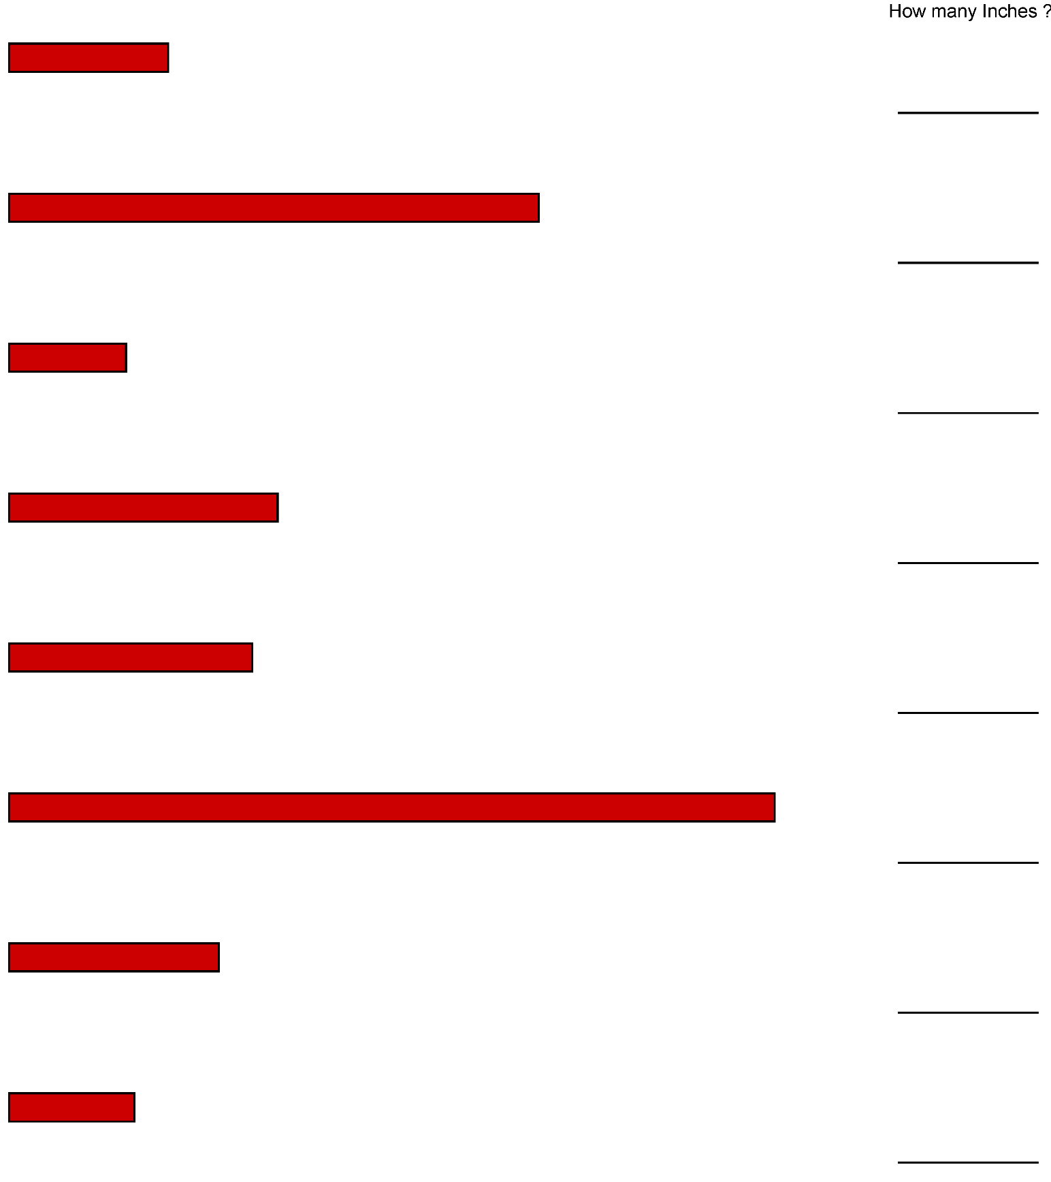

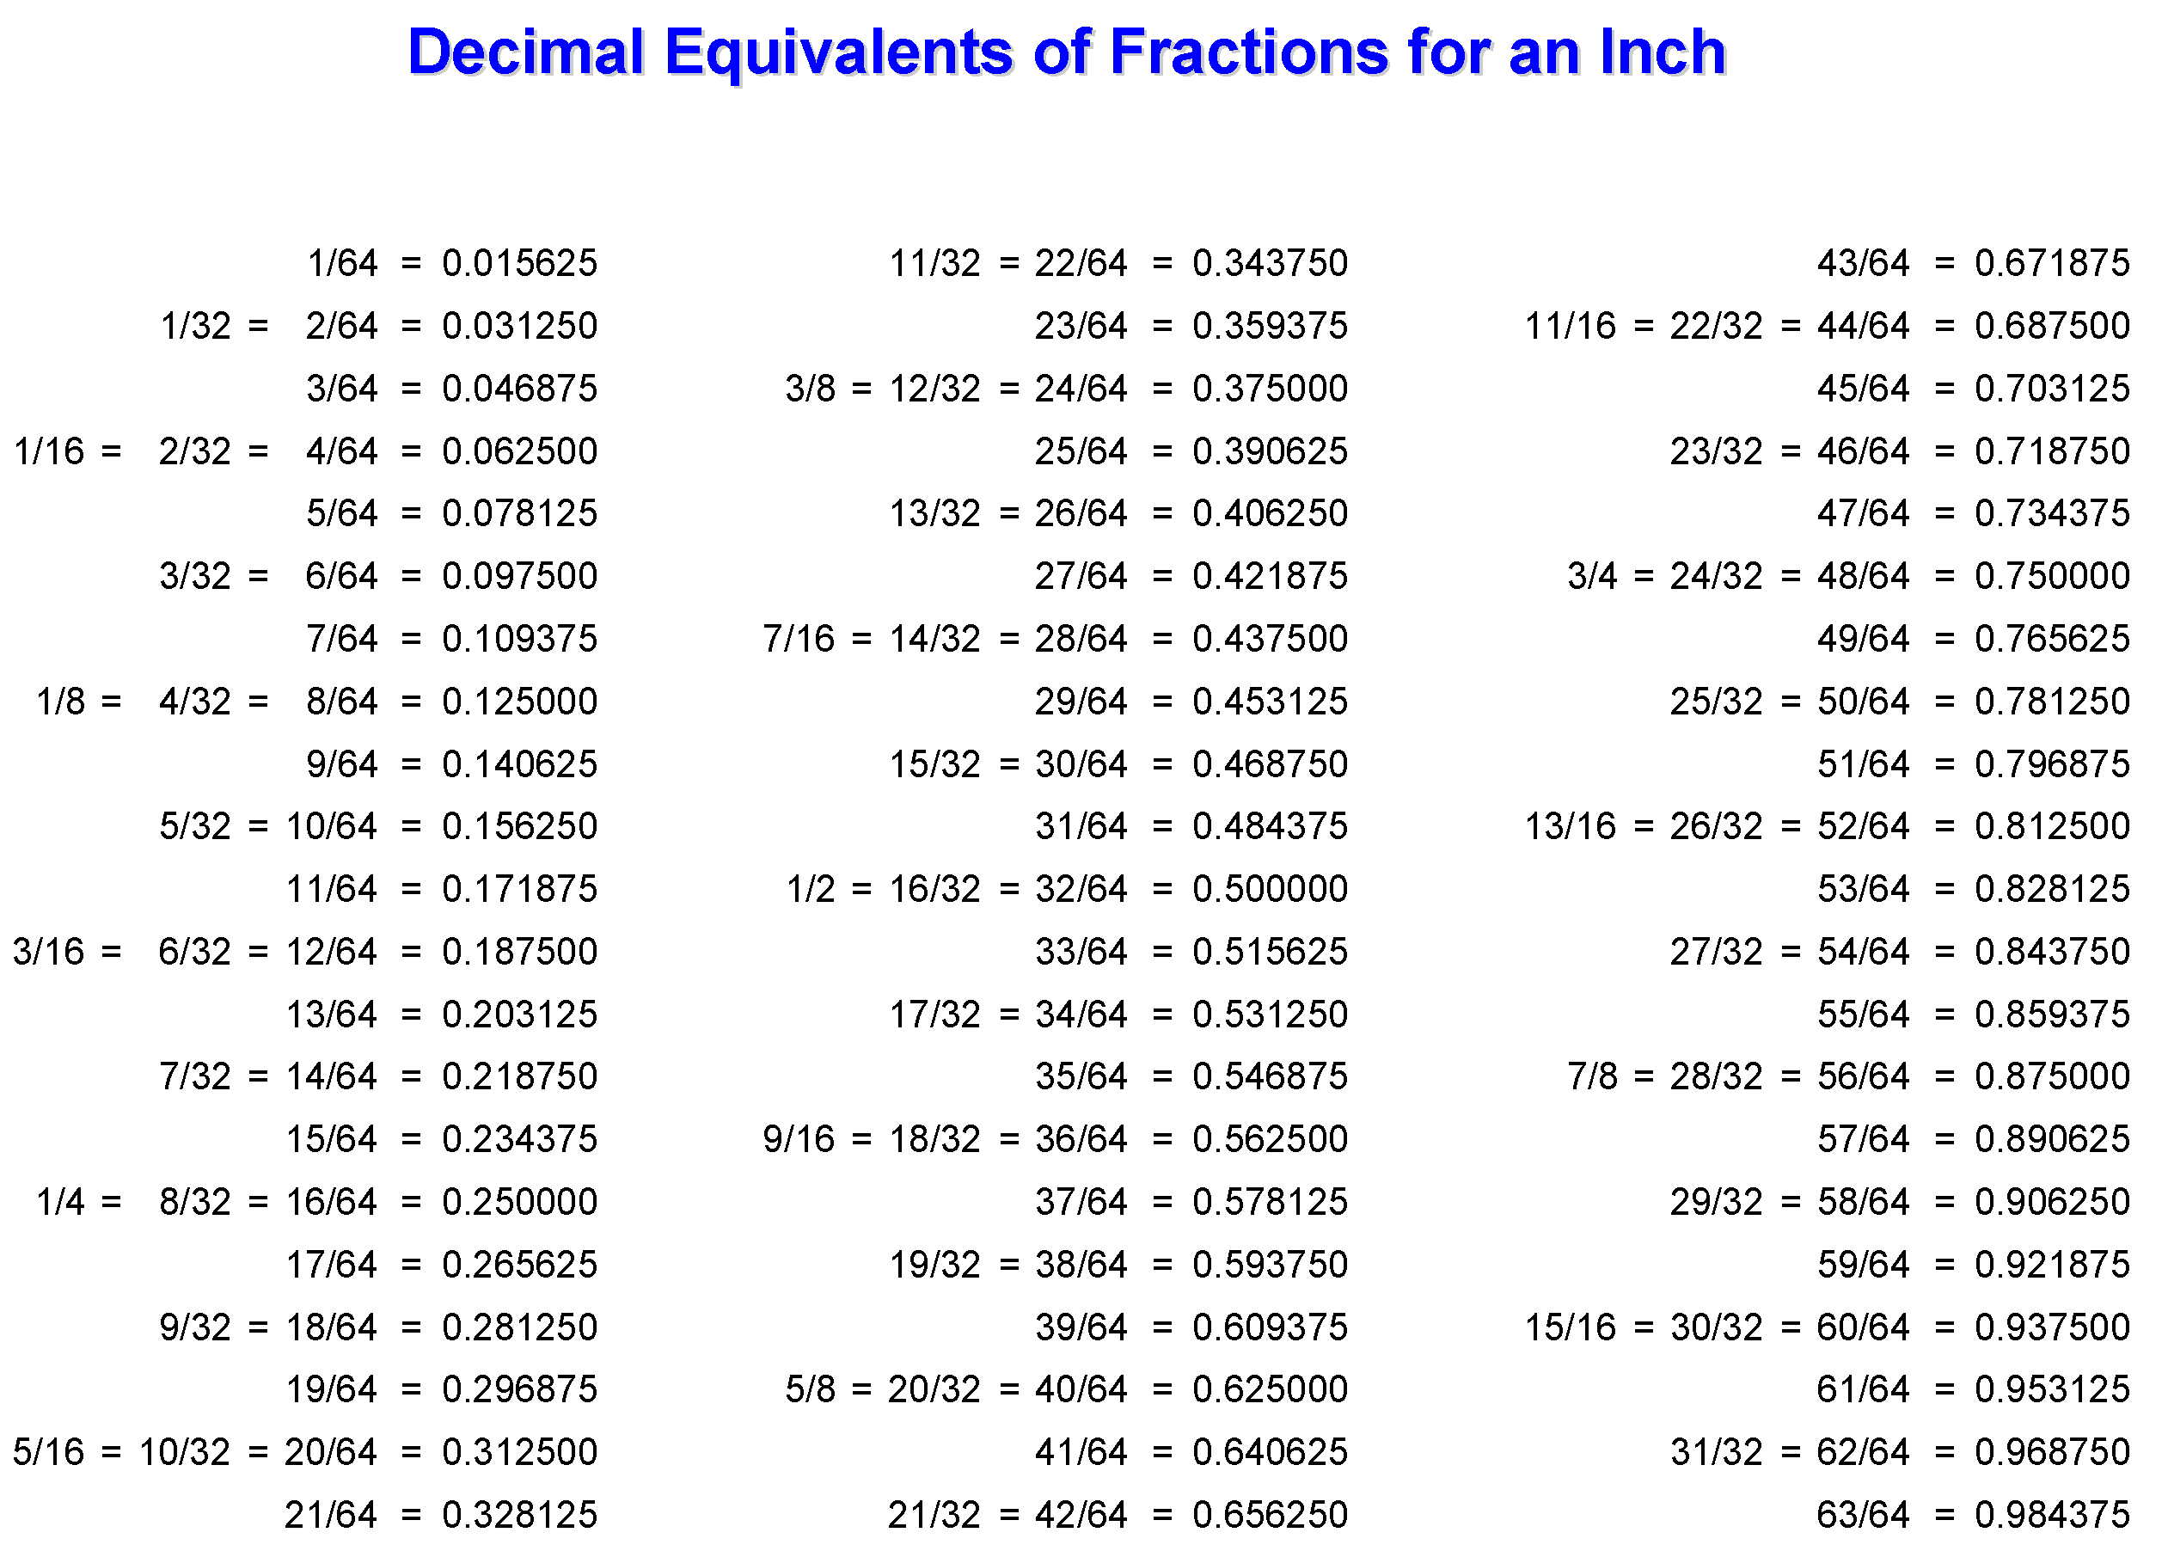
Convert The following Fractions into a Decimal answer (example ½” = 0.50”)
5/16 = _______  14/32 = _______  3/8 = _______  7/8 = _______  1 ¾ = _______  5 9/16 = _______  9 3/16 = _______ | ¼ = _______  6 ½ = _______  7 3/8 = _______

Answer in METRIC
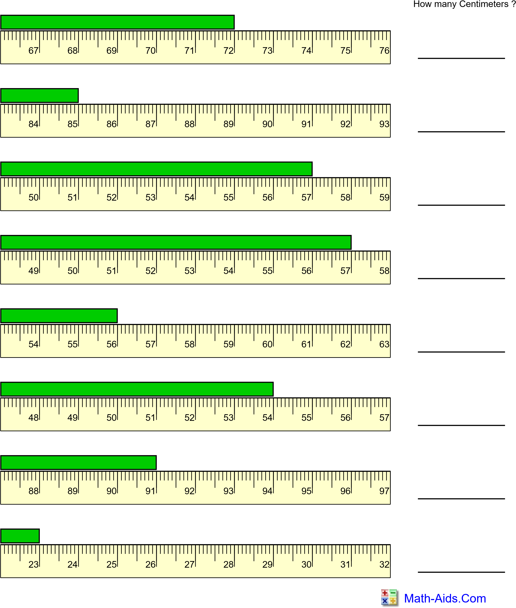
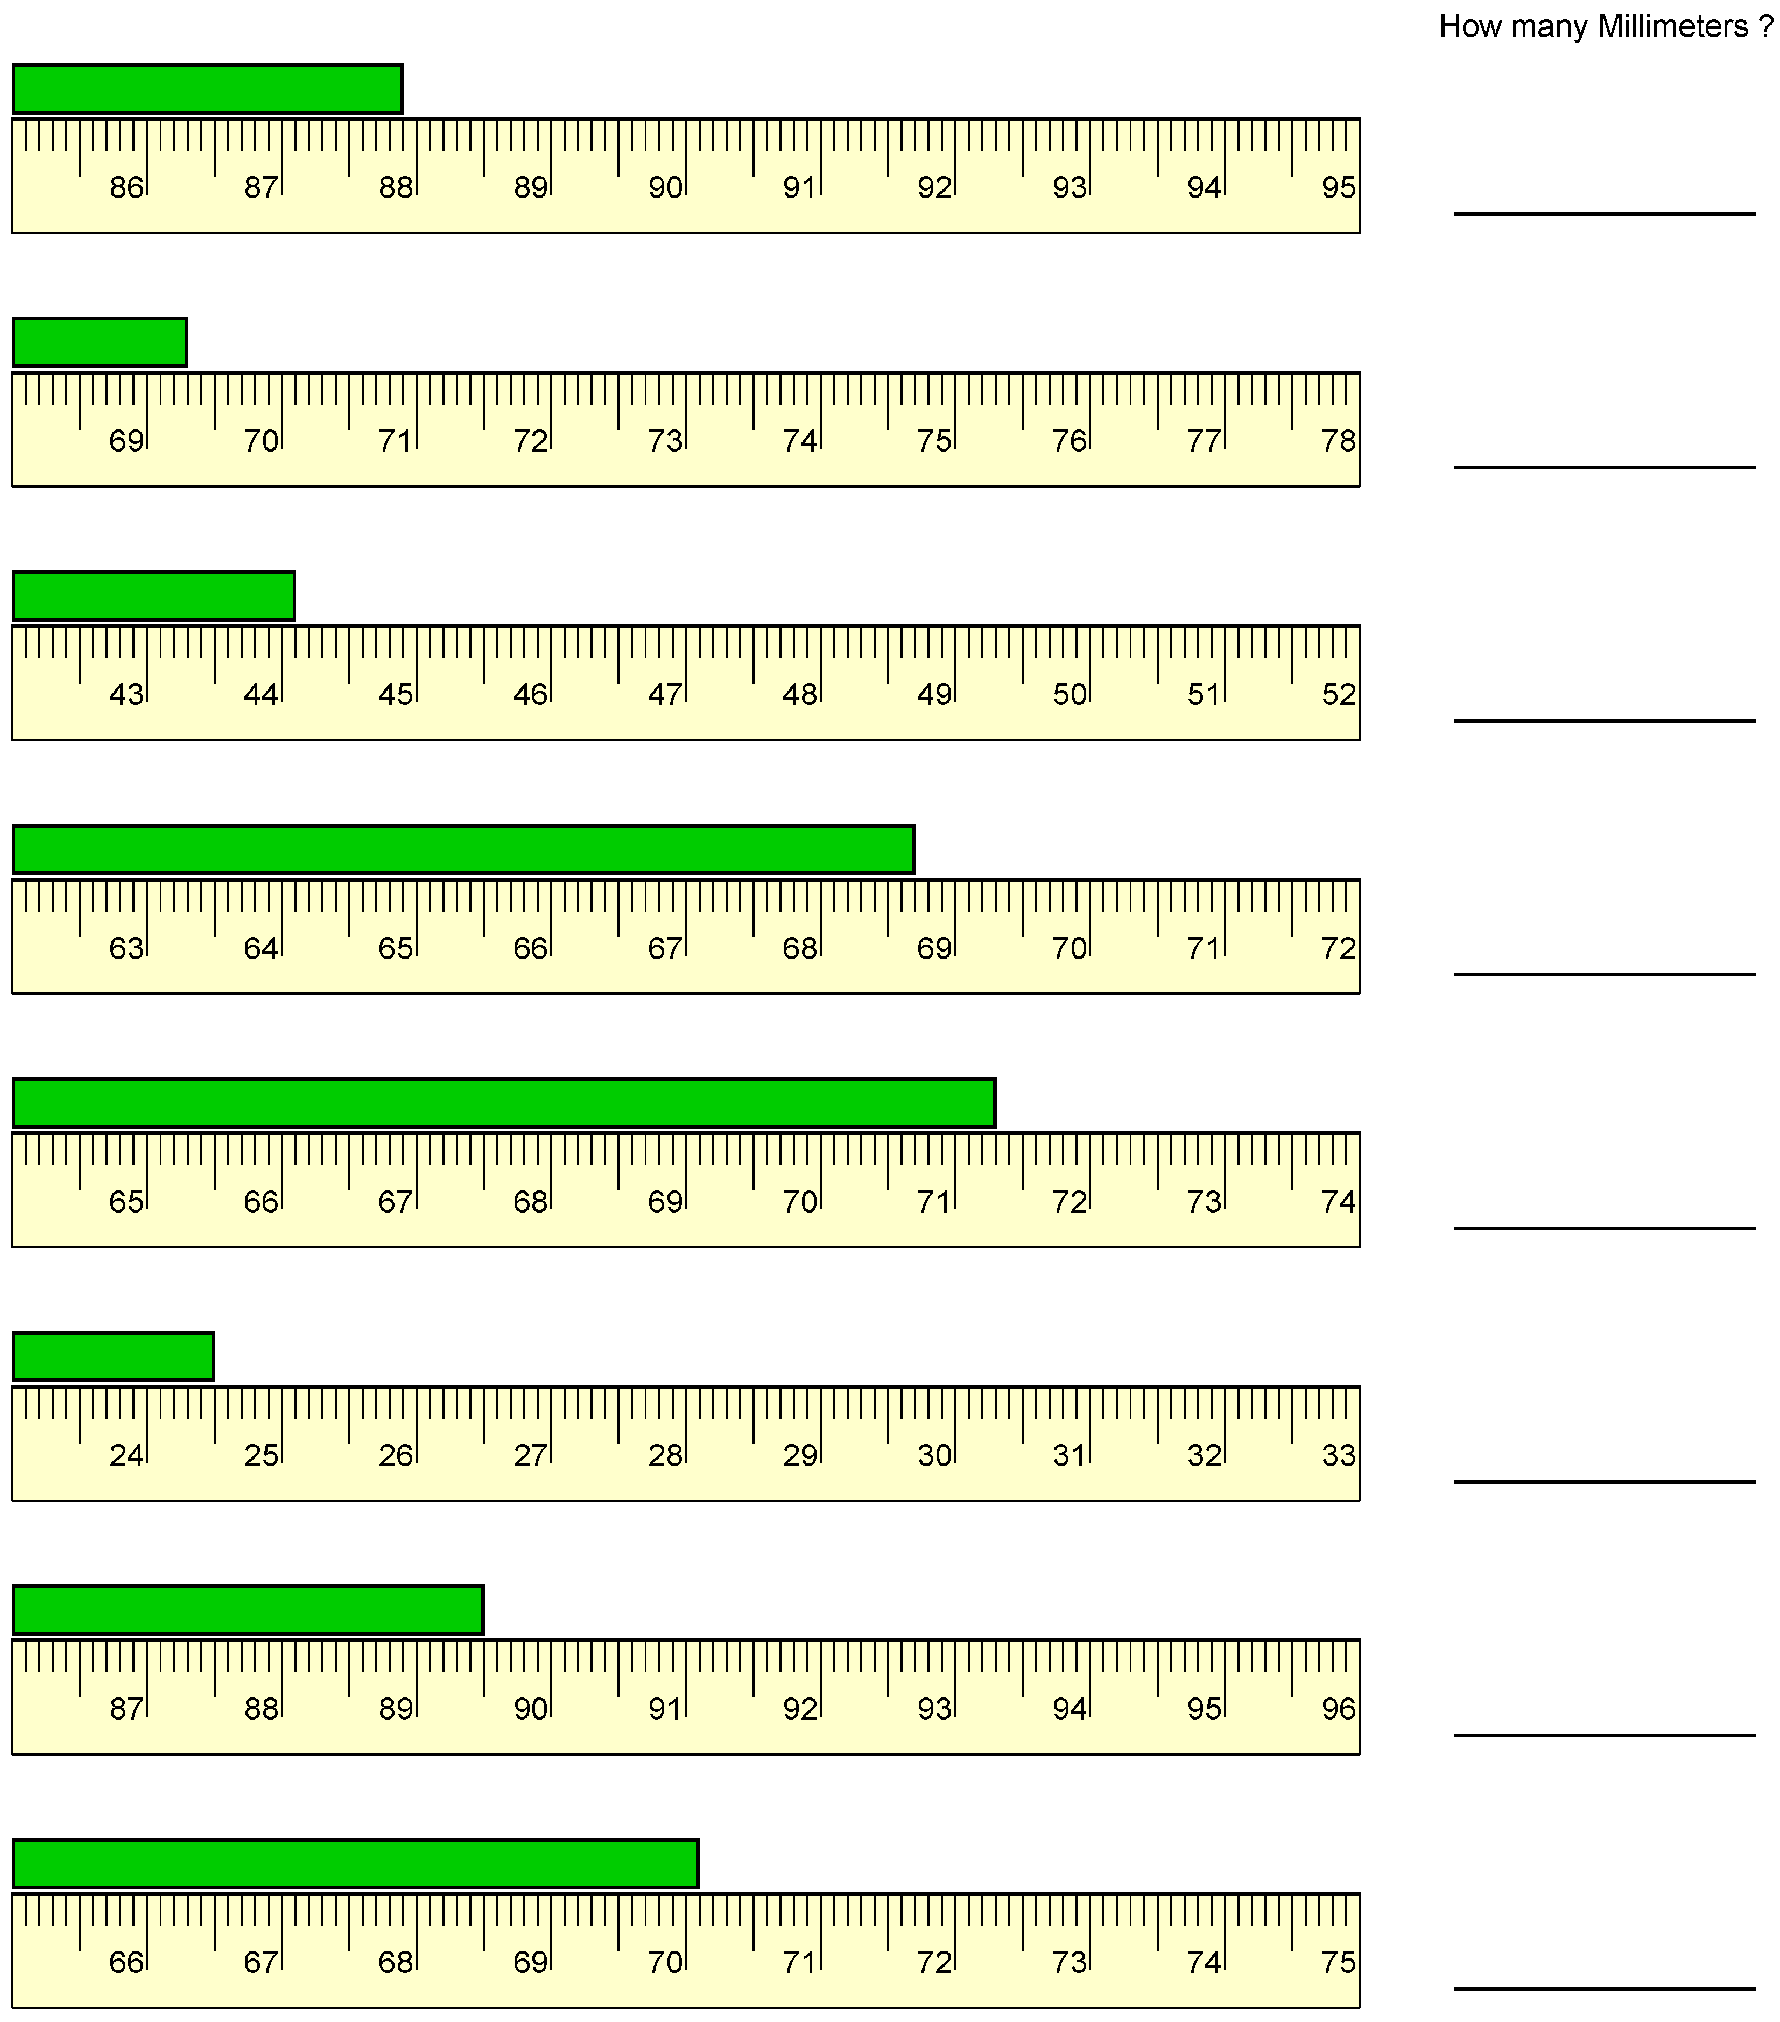
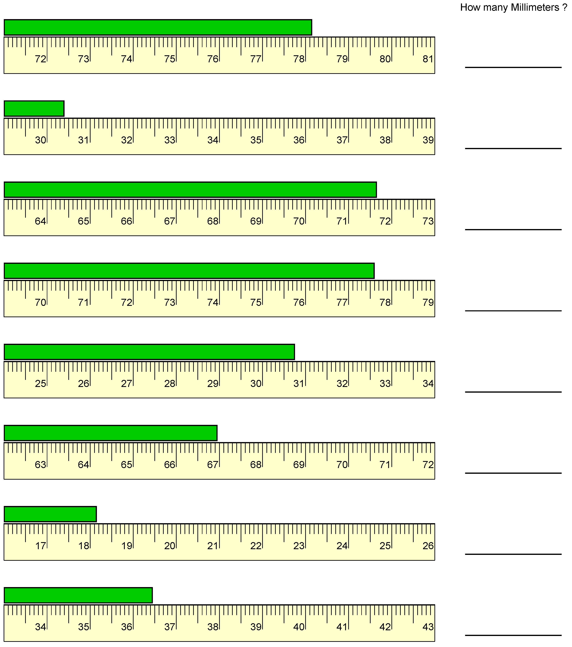

Measure the length in centimeters using a REAL ruler
Round up your answer to the nearest tenth decimal. (Example = 2.55cm)
How many cm?
