Metalwork Alphabet Assignment
Name:
Block:
Date:

This Alphabet assignment is a research and knowledge exercise.
For this exercise you will need to fill in each letter of the alphabet with metal, a tool, a safety rule, or piece of metalworking equipment, description about it, and photo. You may use any resources you have (books, internet, home garage/tools, etc) to do these. Feel free to use some humor with this as long as it does relate to the assignment!
How to find answers? Type in “metal work tool list” or “metal work safety” or “types of metal” in a search engine. You can get as creative as you want with this! You are more than welcome to use wikipedia or something for your descriptions. I did that for the examples below.
How to add an image in a Google Document:
Top menu -> Insert -> “Image” -> choose your option. I personally like to save an image to my device and upload it but you can easily press “Search the web” and easily insert a picture without needing to save it. WOW!
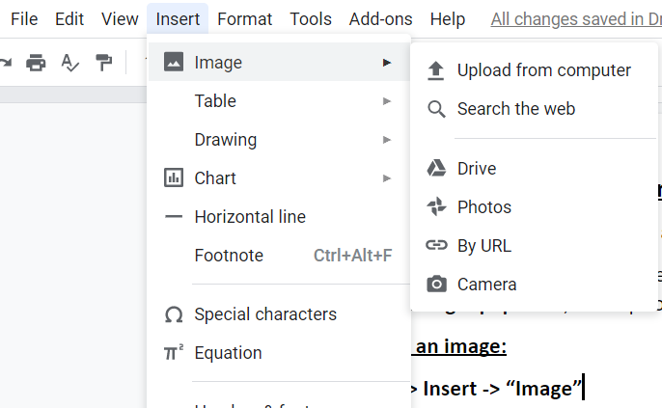
Examples:
Insert picture here:  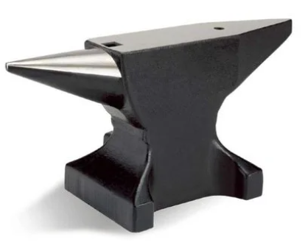 | A is for: Anvil  An anvil is a metalworking tool consisting of a large block of metal (usually forged or cast steel), with a flattened top surface, upon which another object is struck.

Insert picture here:  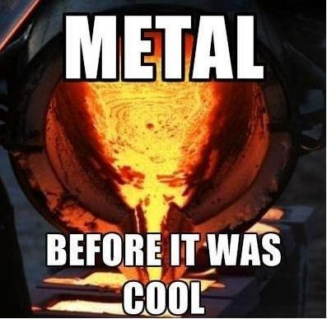 | C is for: casting  Casting is a manufacturing process in which a liquid material is usually poured into a mold, which contains a hollow cavity of the desired shape, and then allowed to solidify.

YOUR TURN!
Insert picture here: | A is for:

Insert picture here: | B is for:

Insert picture here: | C is for:

Insert picture here: | D is for:

Insert picture here: | E is for:

Insert picture here: | F is for:

Insert picture here: | G is for:

Insert picture here: | H is for:

Insert picture here: | I is for:

Insert picture here: | J is for:

Insert picture here: | K is for:

Insert picture here: | L is for:

Insert picture here: | M is for:

Insert picture here: | N is for:

Insert picture here: | O is for:

Insert picture here: | P is for:

Insert picture here: | Q is for:

Insert picture here: | R is for:

Insert picture here: | S is for:

Insert picture here: | T is for:

Insert picture here: | U is for:

Insert picture here: | V is for:

Insert picture here: | W is for:

Insert picture here: | X is for:

Insert picture here: | Y is for:

Insert picture here: | Z is for:

